**Implement Spring Security with Authentication**

**Code:**

**Springboot Application**

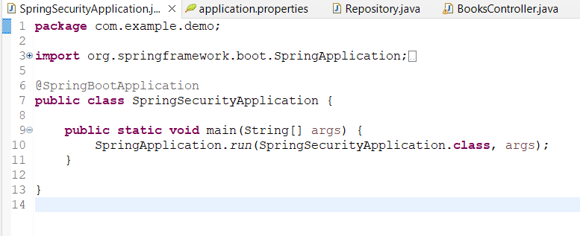

**Pojo bean**

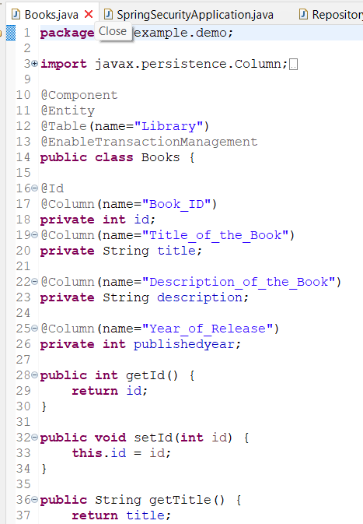

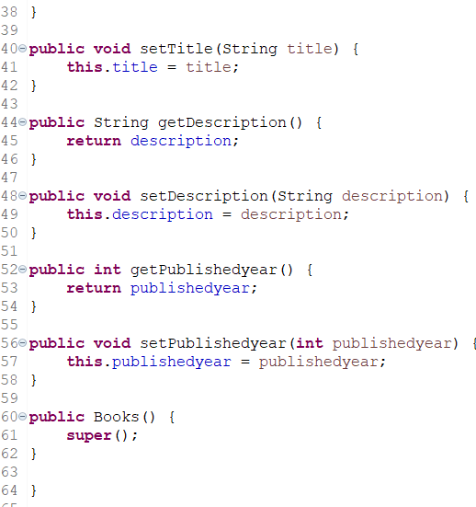

**Repository interface**

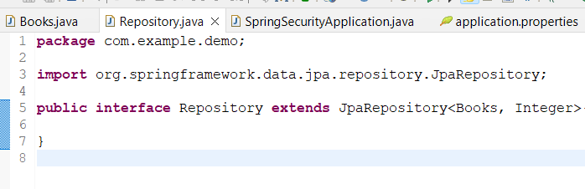

**Controller**

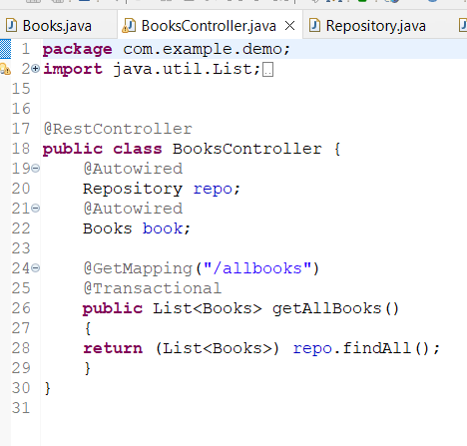

**Application Properties**

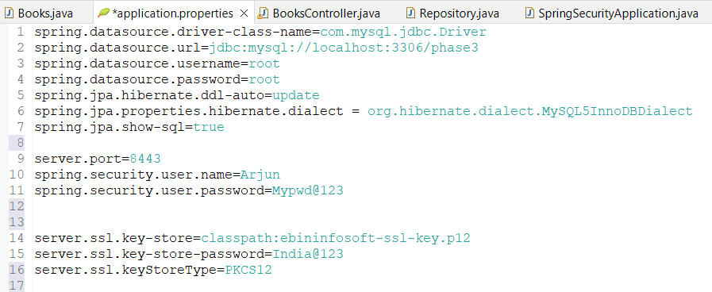

**Output:**

The spring security is achieved by using the spring boot security dependency and also we can make the application secure by using https which is configured in the application.properties and the ssl key is pasted in resources.

Running the application without mentioning the authentication by username and password will generate a password in the console,which is autogenerated each times when the application runs.

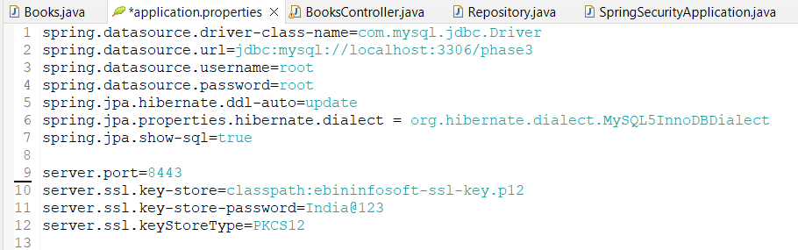

The password generated for authentication by Spring Security

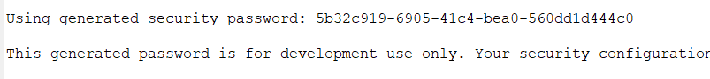

By giving username and password for authentication by User



After running the spring boot application and accessing the page ***“localhost:8443/allbooks”***

It will ask for Authentication because of the dependency of spring security

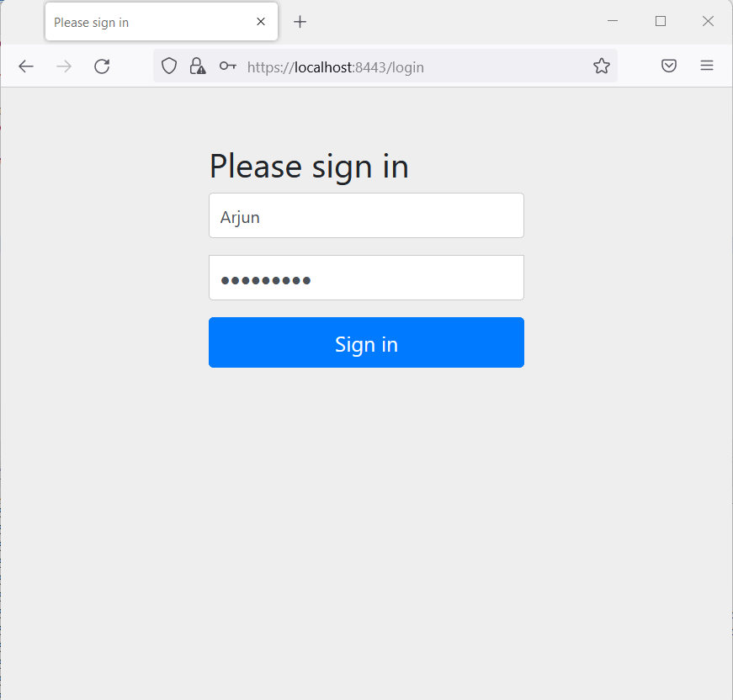

After entering the correct credentials the user is allowed to access the page

In this Controller we are fetching all the books from a table ‘library’.

